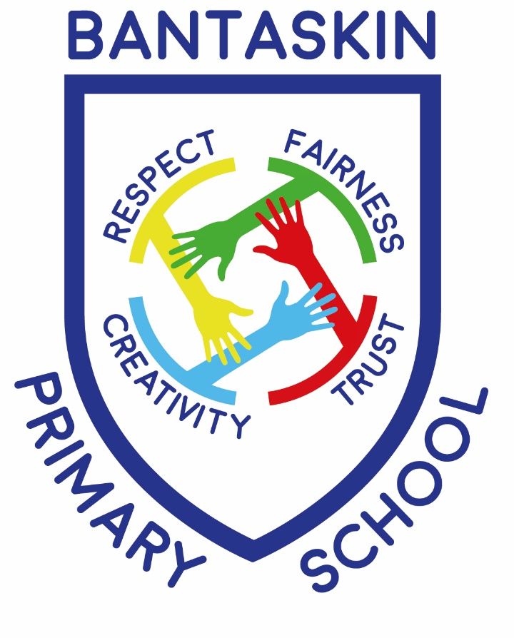

BANTASKIN PRIMARY SCHOOL AND NURSERY CLASS

Inspiring Ambition

Standards and Quality Report Session 2022 – 2023
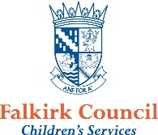

The purpose of the annual Standards and Quality Report (SQR) is to record the successes and achievements in delivering improvement relating to the identified priorities in the improvement plan 2022/23.

Staff at all levels continue to undertake and participate in a range of professional learning and development to support both the identified priorities of the improvement plan and all our children and young people.

This report provides a helpful summary for parents/carers and other stakeholders, of successes and achievements in academic session from August 2022 - June 2023, and outlines priorities for session 2023/24.

Bantaskin Primary School is a non-denominational school situated in the centre of Falkirk. In Session 2022 – 2023 we had a role of 285 children with 11 classes. Across the school classes are formed in different ways based on the number of children at each stage in the school – some classes are composite classes and some are single stream. We also had an ELC class, (currently running with 1140hrs), for 3 to 5 year olds which accommodated 48 children over the week.

Our Senior Leadership Team includes a Headteacher, 1 part-time Depute Headteacher and 2 Principal Teachers (1 full time and 1 part-time). All pupils received 2 hours of PE tuition from a PE Specialist teacher each week and half hour Music tuition from a Specialist Music teacher each week.

Our Support Staff consisted of our School Clerical, 3 full-time Support for Learning Assistants and 2 part-time janitors.

Our Motto

‘INSPIRING AMBITION’

Our Vision

‘Providing a happy, safe and inclusive environment which inspires ambition in everyone to be the best they can be through our core values’.

Our Values
Respect
Creativity
Trust
Fairness

Context of the School/ELC Setting

Bantaskin Primary School is a non-denominational School serving the catchment area of Bantaskine near the centre of Falkirk. Bantaskin has a very strong sense of community, and the school is very proud to play a key role in our community. It is our intention to further increase our activity and profile.

We have 12 classes at present and an ELC class with 285 pupils in total across School and Nursery for session 2021-2022. Our Senior Leadership Team includes a Headteacher, 1 part-time Depute Headteacher and 2 Principal Teachers (1 full time and 1 part-time). All pupils receive 2 hours of PE tuition, with 1 hour from a PE Specialist teacher each week and the other hour from their class teacher and half hour Music tuition from a Specialist Music teacher each week. 14 class teachers (part time and full time) support children’s learning as well as a part time Support for Learning Teacher, YMI instructor and strings instructor.

Our current SIMD Profile is 40.1% (deciles 1-3); 42.7% (deciles 1-4) across the school with FME (Free School Meal Entitlement) of 25.6% (P6&7 only). At present the Scottish Government provides free meal to all children from P1-P5.

We have an exciting diverse community with 16 different languages spoken across our school population. There are a number of children enrolled in our school from the travelling community who attend the school. Our Pupil Equity Funding for this session was £95,000.

Attendance across the school is generally good. Almost all our pupils have an attendance rate of 89% or above and our exclusion rate was zero this session. Robust monitoring procedures ensures prompt measures are implemented to help increase this.

The school continues to have strong partnerships with our families, partners, and the wider community. We work closely together to ensure the best outcomes for our learners. During this session, effective communication methods have strengthened our collaboration with the school community. Positive feedback has been received through forms and our digital engagement tools. We continue to work in partnership with the Inclusion and Wellbeing Service, Speech and Language therapist, active schools.

School improvement priorities 2022 / 2023:
Review of progress for 2022 - 2023
Priority 1: Raise attainment:
- Falkirk Council Moderation programme to be introduced
- Review assessment overview
- Targeted intervention teacher
NIF Priority:  - Improvement in attainment, particularly in literacy and numeracy.  - Closing the attainment gap between the most and least disadvantaged children.  NIF Driver:  - Teacher professionalism  - Assessment of children’s progress  - School Improvement  - Performance information | FC Priority:  - Closing the attainment gap – monitor the impact of PEF and disseminate effective interventions for raising attainment and achieving equity.  - Improving attainment – support schools in gathering and analysing data for improved outcomes, attainment and achievement.
HGIOS4 QI & HGIOELC  2.3 Learning, Teaching and Assessment  3.2 Raising attainment and achievement | Has this work been supported by PEF?  Yes – targeted intervention teacher
Progress
- Moderation process – as outlined by Falkirk Council – was introduced to all staff by a peer class teacher
- Staff worked in trios to identify key elements to assess and plan together. They then moderated the process, delivery and outcome together
- A full evaluation was carried out of the content of the curriculum that we currently have in place, what is delivered, resourced and progressed for all children
- Staff evaluated against national standards (HGIOS) and HMIe reports from other schools
- Assessment overview has been reviewed as a staff
- Various assessments were reviewed as staff to ascertain which ones would meet our needs as a school
- Interventions for literacy (with SflT and Intervention teacher) analysed where gaps lay for children in classes across the school. Focussed work took place at key stages to support improvement for children and raising attainment at key stages.
Impact
- Staff planned and worked collegiately to moderate the learning and teaching cycle
(some of this work was hampered due to the loss of some collegiate time around strike action)
- A greater parity of experiences and quality is being achieved as a result if this collegiate work
- Staff now have a more in depth awareness of what we deliver as a school, where our strengths and needs lie to improve the provision that we have for the children
- Assessment structures have been reviewed with some being removed and new standardised assessment introduced to support staff with professional judgement
- Almost all children are attaining national expected standards in maths/numeracy with the school being on track with the local authority stretch aim (84%)
- Literacy attainment was 79%, 6% behind the stretch aim from the local authority. New assessment tools to analyse key skills and components of the aspects of literacy will be added next session to support improvement in this. Teaching of reading will be a focus.
- Intervention work led to all targeted children making improvements. Of children targeted at key stages (P4, P7) 54% of children previously off track became on track again and achieved the expected level, with all children showing improvement in attainment based on a number of measures (in house assessments, improving in reading book bands, Reading Eggs scores, W.A.V.E scores)
Next Steps
- Use new writing and reading assessment tools throughout the session
- Refocus the moderation programme for next session
- Refresh of our school rationale and how we structure our curriculum
- Focus on teaching of reading and key component of that to support skills progression and raising attainment

Review of progress for 2022 - 2023

Priority 2: Supporting Health and Well-being development:
- Develop new school relationships policy
- Establish new whole school HWB planners
- Re-engaging with families following COVID recovery
- Begin our Rights Respecting School journey
NIF Priority:  - Improvement in attainment, particularly in literacy and numeracy.  - Closing the attainment gap between the most and least disadvantaged children.  NIF Driver:  - Teacher professionalism  - Assessment of children’s progress  - School improvement  - Performance information | FC Priority:  - Closing the attainment gap – monitor the impact of PEF and disseminate effective interventions for raising attainment and achieving equity.  - Improving attainment – support schools in gathering and analysing data for improved outcomes, attainment and achievement.
HGIOS4/HGIOELC QIs  2.3 Learning, teaching and assessment  3.2 Raising attainment and achievement  2.5 Family learning  2.7 Partnerships | Has this work been supported by PEF?  Yes – in bold
Progress
- New HWB planners are now in place to support progression of RSHPE and HWB across the school
- Training for all teaching staff has taken place to explain how to use the progression pathways to support planning at each stage across the school
- Children’s mental health was focused on for the whole school, considering strategies to support yourself and ways to seek help
- Whole school questionnaires have been issued for families to seek opinions and views on a range of topics
- Answers supplied have been analysed by staff to seek further ways to engage with and involve families in the life of the school
- Held a series of ‘open doors’ events over the course of the session in a number of classes
- All staff have been trained in positive relationships with ‘When the Adults Change’ organisation
- As a staff we carried out professional reading to support the development of our relationships policy
- All carried out personal CPD online regarding relationships policy
- Training for staff in beginning to incorporate Children’s Rights in to class practise
- Whole school introduced to UNCRC through assemblies and as directed work for each class
- All classes introduced to key articles and language in relation to aspects of IDL and daily class language
Impact
- All staff now following new HWB planners implementing all aspects of HWB Curriculum
- RSHPE now fully being covered and implemented across the school for all children
- Children being supported with the key language to use to discuss their own health (physical and mental)
- With key adults some children are beginning to express how they are feeling mentally when dealing with various situations in life and beginning to consider/discuss suggested strategies to help themselves cope with difficulties that they may be facing
- ‘Almost all’ families have been involved in an activity with their child’s class this session (school trips, ‘Meet the Teacher, Open events, Christmas events, Scots events)
- An increase in families supporting and attending parents consultations has been noted with 94% of children having family members attending consultations (up from 87% the previous session which had been wholly online). This session we offered both online and in-person as an option.
- Communication strategy developed to support further engagement with families
- Homework strategy establish to support engagement/involvement and raising attainment in literacy and numeracy
- Almost all children able to identify a number of ‘Articles’ from UNCRC and beginning to use the language of ‘Rights’ in school (mainly in relation to HWB indicators)
- School achieved Bronze Status RRS
- New positive relationships policy is now being implemented across the school
- At this stage a reduction in incidents in the playground or in school is not markedly evident, however a calm and purposeful atmosphere is clear cross the school
- Pupils and families have commented that an ethos of more nurturing approaches and celebrating the positive behaviours we are seeking to encourage, is more evident for all to see
Next Steps
- Further develop our relationships policy
- Seek further supports and training for staff regarding nurturing principles
- Seek further ways to integrate families in to the life of the school
- Embed our communications strategy (following on from consultation process this session)
- All classes to hold ‘open doors’ events throughout the session to invite families in to school
- Further consultation with families on developing RSHPE across the school, explaining the progressive planning approach now developed
- Commence work on further embedding RRS across all aspects of school life
- Formulate Silver Status Action plan (RRS)
- Restorative Practices AND Nurturing Principles to be introduced further across the school

Review of progress for 2021 - 2022

Priority 3: Curricular development:
- Establish 1+2 progressive planners for the whole school
- Establish RME progressive planners for the whole school
- Established an Art planner for the whole school
NIF Priority:  - Improvement in children and young people’s health & wellbeing.  NIF Driver:  - School Improvement  - Parental engagement | FC Priority:  - Closing the attainment gap – monitor the impact of PEF and disseminate effective interventions for raising attainment and achieving equity.
HGIOS4/HGIOELC QIs  1.2 Leadership of learning  2.2 Curriculum  2.5 Family learning  2.7 Partnerships  3.1 Ensuring wellbeing, equality and inclusion  3.3 Increasing creativity and employability | Has this work been supported by PEF?  No
Progress
- New MLPS planners in place for the whole school
- Supports structures in place for teaching of 1+2 languages
- Training delivered to all staff
- A French club took part at lunchtime, sharing food, playing games and using the language in real contexts
- New RME progression planners have been completed and implemented across the school
- Training has been delivered to all staff
- A new assembly overview has been established welcoming other faith groups in to the school to share the beliefs of their faith and provide the children with the opportunity for personal reflection (2 local Christian denominations, local Catholic Priest, Foodbank, Sikh Temple, Local Mosque)
Impact
- All children have received a progressive taught programme from the RME curriculum
- Most children are now able to name key faith groups in our locality and country and start to discuss what their own beliefs may be in relation to/compared with them
- New assembly overview for the session has ensured that Religious Observance has been offered to all children across the school, providing opportunities for personal reflection on key aspects of development and in relation to stories from key religious texts
- All children receiving a progressive programme of taught languages across the school (French P1-7, Spanish P4-7, BSL across the school)
- Conversational language skills have improved in all classes
- Skills progression is being following for Art ensuring that the curriculum is being implemented to meet the needs of the children
Next Steps
- Other aspects of the Expressive Arts to be fully developed – Drama and Dance for next session
- Fully embed the 1+2 planners across the school
- Continue to seek to extend religious observance to include other local faiths and groups
- As part of developing our ‘Learning and Teaching’ Policy next session, practice and active approaches to teaching languages to be further developed

Review of progress for 2022 – 2023
ELC Priorities - Parental Engagement / Listening and Talking

- Staff to develop to skills in how they interact with children leading to applying for the ‘Diamond Communication Award’
- As part of the ‘Recovery Process’ to re-engage with families in the life of the ELC setting in the children’s learning
NIF Priority:  - Improvement in children and young people’s health & wellbeing.  NIF Driver:  - School Improvement  - Parental engagement | FC Priority:  - Closing the attainment gap – monitor the impact of PEF and disseminate effective interventions for raising attainment and achieving equity.
HGIOS4/HGIOELC QIs  1.2 Leadership of learning  2.2 Curriculum  2.5 Family learning  2.7 Partnerships  3.1 Ensuring wellbeing, equality and inclusion  3.3 Increasing creativity and employability | Has this work been supported by PEF?  No
Progress
- Staff undertook ‘Diamond Communication Award’ training
- Staff now using this approach with children to increase interaction
- Evidence has been gathered and awaiting assessment for ‘Diamond Award’
- ELC staff offered a range of events to include a range of families including, ‘Big Cook Little Cook, fitness sessions, book bug, St. Andrews Day and Burns celebrations, Slow Pedagogy, Information sessions for families around ASD
Impact
- All have benefitted from training in interacting with children and are confident in using these skills to support interaction with children
- Throughout the course of the session ‘Almost all’ families attended at least one event with the staff (closer to 95%)
- Fitness sessions were the most well attended with engagement being ‘Almost all’ children having family members in attendance
- ‘Big Cook, Little Cook’ continued to be well attended with ‘Almost all’ children able to attend these sessions with a family member
- Feedback positive was received for all who attended
- In consultation with families we altered the times of sessions to coincide with the end of the school day (i.e. starting at 2:30) making accessing these sessions more convenient for families in terms of managing childcare
- Lending library was re-established supported by families. ‘All’ children have been able to be part of this.
- The impact of the speech and language interventions used this session was measured using the Renfrew Word Finding vocabulary assessment. The results show that 82% of our ante pre-school children have a vocabulary score of within 6 months of their chronological age.
- In addition to this 74% of our pre-school children are performing 6 months or above their chronological age – a 15% increase on the start of the session.
Next Steps
- Continue to gather evidence to support ‘Diamond Award’ assessment arranged in conjunction with Speech and Language Therapist
- Continue to offer more opportunities for families
- Continue to consult with parents regarding the needs of the families. Use information gathered to provide appropriate workshops to reflect the needs of the current children/families within the setting

Section 3
Key priorities for School Improvement Planning 2023- 2024
This section should articulate with the school improvement plan for the forthcoming session or plan cycle. It should focus on a small number of key improvement priorities which will be expressed as outcomes for learners (as they will appear on the strategic overview of the new improvement plan).

2.3 Learning, teaching and assessment
- Establish a ‘Bantaskin Standard’ (Learning and teaching policy)
- Review reading provision – resources, pedagogy, pressure points, assessment
- Moderation- using Falkirk Council structure of moderation of Learning, teaching and assessment AND moderation across the cluster with a focus on teaching of writing

Inclusion and equality
- PDSA with a focus on inclusion in each classroom
- Apply for Silver RRSA award
- Further develop our behaviour/relationships policy to support all pupils and link with nurturing principles

Curricular development
- Progressive skills planners for Expressive Arts
- Initial development of ‘Purposeful Play’ / ‘Play is the Way’ to support learning, teaching and assessment in the Early Years
- Review of our curriculum rationale and the curriculum that is offered across the school, the connections, context and links across areas

What is our capacity for continuous improvement?
A brief statement that reflects your current evaluation of your school’s capacity for continuous improvement. This should link to each of the QIs you have graded below.
- All staff involved in a School Improvement Group to take forward aspects of school improvement
- All staff are eager – and have the capacity – to lead change across the school, both in terms of attainment, curricular development and the wider life of the school. This will be further developed next session by following the PDSA method of improving practise in every class.
- Effective liaison meetings take place between staff and SLT with staff analysing data to identify next steps for each child and ways to increase attainment
- Planning for teaching takes place in teams and levels to support effective learning
- Strong evaluation has taken place, focusing on our Improvement priorities and national standards.
- Strong evaluation has taken place, using the Quality indicators for 2.3 and 1.2 to identify next steps in our continued improvement. A 3 year cycle for evaluating all QIs has now been agreed.
- Effective evaluation of school progress to be scheduled in on a termly basis

Summary of Self-Evaluation – Reference QIs

Primary / Secondary
Self-Evaluation of the Core HGIOS?4
 | Self-Evaluation Grading
1.3 Leadership of change | Good
2.3 Learning, Teaching & Assessment | Good
3.1 Ensuring Equality, Inclusion & Wellbeing | Good
3.2 Raising Attainment & Achievement | Good

ELC Classes / ELC Centres
Self-Evaluation of the Core HGIOELC? / Quality Framework
 | Self-Evaluation Grading |  | Self-Evaluation Grading
1.3 Leadership of change | Very Good | 1.1 Nurturing Care and Support | Good
2.3 Learning, Teaching & Assessment | Very Good | 1.2 Play and Learning | Very Good
3.1 Ensuring Wellbeing, Equality & Inclusion | Very Good | 2.2 Children experience high quality facilities | Very Good
3.2 Securing Children’s Progress | Good | 3.1 Quality assurance and improvements are well led | Very Good
3.2 Securing Children’s Progress | Good | 4.3 Staff Deployment | Very Good

